Supplementary Material For “An Empiricist’s Guide to Modern Coexistence Theory for Competitive Communities”

Supplementary Material Appendix A: Simulation of Experiments to Measure ND and RFD and Predict Coexistence
In this supplement, we present numerical simulations that compare the outcomes from three methods for measuring ND and RFD and also the NFD method for predicting coexistence. We used Tilman’s parameterized consumer-resource model for two species of phytoplankton competing for essential resources (Tilman 1977). Annotated code for the simulations is provided in a supplemental file. Simulations were performed using the function NDSolve in Mathematica 11.2 (Wolfram Research), employing a variable step size. For each set of resource supply concentrations, we performed four simulations: (1) species 1 as a monoculture, growing from rare to near its equilibrium density; (2) species 2 as a monoculture, growing from rare to near its equilibrium density; (3) species 1 at its equilibrium density, with species 2 invading from rare; (4) and species 2 at its equilibrium density, with species 1 invading from rare. Additionally, we performed numerical simulation where both species are introduced at low densities and asked whether they coexist at the equilibrium. For each set of simulations, we manipulated the supply concentration of the two resources in order to determine whether the methods consistently agree.
We implemented the Lotka-Volterra method using information from all four simulations described above. Simulations 1 and 2 were used to estimate r_{i}, K_{i}, and intraspecific interaction coefficients α_{ii}. We estimated the intraspecific interaction terms using two different approaches (Section 1.2). First, we estimated α_{ii} as the slope of the relative growth rate versus population density (sign reversed) as the monoculture simulations approach equilibrium (Figure 1). Alternatively, we used the assumption that α_{ii}=1/K_{i}. We then used the parameter values from the monocultures, along with simulations 3 and 4, to solve Equation 2 when each species is at low density and the other is near equilibrium. We used all four interaction coefficients to calculate ND and RFD using Equations 3 and 4. We implemented the sensitivity method following Equations 5 through 7, using output from all four simulations. The raw RFD values from the sensitivity method were converted to the same ordering as used in the other methods (species i in the denominator rather than the species with the greater sensitivity).
As described in Appendix C, the NFD method cannot be used to get ND and RFD estimates that are consistent with the other methods, but nonetheless this method can be used to predict coexistence based on the same criterion. However, as shown in Supplementary material Appendix A Figure A1 (using the Lotka-Volterra model), accuracy of the NFD method depends on the range of frequencies used to get the slope and elevation. To illustrate how the non-constant NFD slope is problematic in predicting species coexistence, we used the simulations of mutual invasion (simulations 3 and 4), described above, to construct pairs of each species’ frequency and their growth rate in a saturated community. For all of these simulations, we used only supply concentrations of the resources that are known to allow for coexistence. For each value of a species frequency between 0 and 1, we calculated the slope of growth rate versus frequency. Supplementary material Appendix A Figure A1 shows that this slope is not constant and actually changes sign depending on the species’ frequencies used. Thus, using only the slope of the NFD relationship is inadequate to predict coexistence.
Next, we used both the slope and elevation from the NFD method to extrapolate to frequency of 0 and predict whether the species is capable of invasion from rare (Figure A1 panels A and B). Supplementary material Appendix A Figure A1 shows that for supply conditions known to allow coexistence, the accuracy of the predictions from the NFD method depends on the range of frequencies over which the slope of NFD was measured. We discuss two points (A and B in Supplementary material Appendix A Figure A1) to explain this effect. At the point labeled “A”, the slope of NFD for species 1 predicts a positive growth rate as frequency approaches 0, but at the complementary frequency of species 2, the slope of species 2’s NFD predicts a negative growth rate when rare. However, based on the other 3 methods, numerical simulation, and Tilman’s resource ratio theory, the species are predicted to coexist. Thus, measuring NFD under the red regions in Supplementary material Appendix A Figure A1 will incorrectly predict exclusion even though the species will coexist. At the point labeled “B” in Supplementary material Appendix A Figure A1, the slope and elevation of NFD for both species predicts a positive growth rate when rare. This region, depicted in blue, includes the equilibrium frequency for the two species. If an empiricist made their measurements between frequency of ~0.05 to ~0.85 for species 1, and used the slope of NFD, they would incorrectly predict that the species will not coexist. Since the frequency at which the species reach equilibrium depends on the resource supply ratio, there is no single frequency of the species that consistently leads to the correct predictions (Supplementary material Appendix A Figure A1). While certain intermediate frequencies of the two species can be used to make accurate predictions, an empiricist would not know these frequencies without performing the competition experiments or examining frequency dependence across the entire range of frequencies. As a result, the only reliable way of implementing the NFD is to measure the slope and elevation for each species where its frequency approaches zero.
Next, we compared the four methods including the sensitivity method, the method based on Tilman’s CRM, the Lotka-Volterra method, and the NFD method using the numerical simulations described above. Under specific assumptions, the methods gave the same prediction regarding coexistence (Supplementary material Appendix A Figure A2), though the methods did not produce consistent estimates of ND and RFD (Figure 6).
For the NFD method, accurate predictions required that the slope of NFD was evaluated approaching frequency of zero for each species (i.e. invasion conditions). In Supplementary material Appendix A Figure A2 d-f, we show that evaluating the NFD slope at other frequencies leads to the wrong predictions. We used the NFD plot to evaluate coexistence at three frequencies, including near 0% (panel c of Figure A2) and 50% (panel e), and either with or without considering the elevation in addition to the slope (panels d, f). We see that using the NFD slope evaluated at near 0% frequency will consistently yield accurate predictions of species coexistence that match the those of the other methods.

Supplementary Material Appendix A Figure A1. Results of simulation experiments using the NFD method. Panels a and b show per capita growth rate versus the frequency of species 1 and 2. At any frequency of the two species, the NFD method requires that we use the slope to extrapolate and estimate the growth rate when frequency approaches zero (the extrapolated vertical intercept). For frequencies where this method predicts mutual invasibility for both species, i.e. species can coexist, the lines are blue. For frequencies of the two species where the method leads to the incorrect prediction, the lines are red. Both species have positive growth rates when their frequency approaches zero, indicating that they are mutually invasible. Panel c shows the accuracy of the NFD method as a function of the supply Si:P ratio and the frequency of the two species at which the method was applied. The vertical dashed line represents the slice depicted in panels a and b. For all of the Si:P ratios shown in panel c, the species are mutually invasible and will coexist. This plot indicates that using NFD will often predict that the species will not coexist, when in fact they do coexist. This is important because without examining the full range of species frequencies in an experiment, one would not know whether and where the relationship between frequency and growth rate is non-linear.

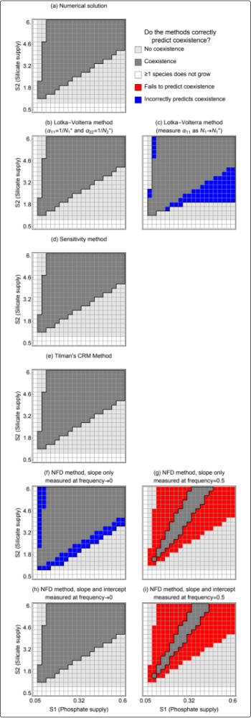
Supplementary Material Appendix A Figure A2. Results of simulation experiments comparing predictions from the Lotka-Volterra and NFD methods.
Supplementary Material Appendix B: Relating the Sensitivity Method to Chesson’s Definition of ND and RFD Using the Lotka-Volterra Model
Here we show that sensitivity method is identical to the Lotka-Volterra method given the specific limiting assumptions of the sensitivity method. To do this, we derive the sensitivity metric (S_{i}) from the Lotka-Volterra competition model (Equation 2). The μ_{i} in main text Equation 7 is the maximum per capita growth rate in monoculture, equal to r_{i} in main text Equation 2. The μ_{ij} is the invasion growth rate, so that we can replace N_{j} with species j’s carrying capacity, K_{j}, and replace N_{i} with 0, so that μ_{ij}=r_{i} (1-α_{ij} K_{j}). Using this substitution, we show in Equation B1 that the sensitivity metric (S_{i}) is the equilibrium density of species j (K_{j}) multiplied by the per capita competition coefficient (α_{ij}).
$S_{i}≡\frac{μ_{i}-μ_{ij}}{μ_{i}}=\frac{r_{i}-r_{i}\left(1-α_{ij}N_{j}^{*}\right)}{r_{i}}=α_{ij}K_{j}$ (B1)
Since the intraspecific competition coefficients in the Lotka-Volterra model are equal to the inverse of the equilibrium population density for the monoculture ($α_{ii}$ =$\frac{1}{K_{i}}$), the sensitivity metric can be shown to be equivalent to the ratio of interspecific to intraspecific interaction coefficients (Equation B2).
$S_{i}=α_{ij}K_{j}=α_{ij}\frac{1}{α_{jj}}=\frac{α_{ij}}{α_{jj}}$ (B2)
From this substitution, we can relate the sensitivity metric to Chesson’s ND (Equation B3), RFD (Equation B4), and use these estimates to assess the conditions for coexistence (Equation 1)
$ND=1-\sqrt{\frac{α_{ij}α_{ji}}{α_{ii}α_{jj}}}=1-\sqrt{S_{i}Sj}$ (B3)
RFD = $\sqrt{\frac{α_{ij}α_{ii}}{α_{jj}α_{ji}}}=\sqrt{\frac{S_{i}}{S_{j}}}$. (B4)
Supplementary Material Appendix C: Relating the Negative Frequency Dependence Method to Chesson’s ND and RFD
Conceptually, when the per capita growth rate is being plotted against the frequency of the focal species, the NFD slope is actually the “per-frequency” impact on the per capita growth rate of each species. Because this slope is fundamentally different than the interaction coefficients in the Lotka Volterra model, we attempt to derive the NFD slope and intercept from the two species Lotka-Volterra competition model (Equation 1). Since there is no variable representing each species’ frequency in the Lotka-Volterra model, we have to assume a fixed community density, B. Also note that the interaction coefficients used here This assumption also satisfies the assumption of the NFD method that the community density is always saturated. Fixing the community density makes the interspecific density dependence, α_{ij}, equivalent to frequency dependence (Adler et al. 2007), and allows species’ frequency to be represented by N_{i}/B. The two-species Lotka-Volterra competition model can then be rewritten as follows
$\frac{1}{N_{i}}\frac{dN_{i}}{dt}=r_{i}\left(1-\frac{α_{ii}N_{i}+α_{ij}\left(B-N_{i}\right)}{B}\right)$ (C1)
, where B is the fixed community density and one unit decrease of N_{i} will lead to one unit increase of N_{j}. From Equation C1, we derive the NFD slope and intercept in the following equations.
$NFD slope≡\frac{∂\frac{1}{N_{i}}\frac{dN_{i}}{dt}}{∂\frac{N_{i}}{B}}=\frac{∂\frac{1}{N_{i}}\frac{dN_{i}}{dt}}{\frac{1}{B}∂N_{i}}=B\frac{∂\frac{1}{N_{i}}\frac{dN_{i}}{dt}}{∂N_{i}}=r_{i}\left(α_{ij}-α_{ii}\right)$ (C2)
$NFD intercept≡r_{i}\left(1-α_{ij}\right)$ (C3)
In Equation C2 the NFD slope becomes constant, which means that species’ per capita growth rate linearly depends on its frequency.
In addition, from Equations C2 and C3, we argue that both NFD intercept and slope should be used with caution in evaluating Chesson’s inequality. First, the NFD intercept represents whether species can successfully invade a steady-state population of its competitor at its carrying capacity, so it can be used to accurately assess mutual invasibility. However, neither the difference nor the ratio of two species’ NFD intercepts (Equations C2 and C3) take an analogous form to Chesson’s definition of ND and RFD. Thus, while the NFD method can correctly predict mutual invasibility, the NFD intercept and slope should not be interpreted as RFD and ND in order to evaluate Chesson’s inequality.
The utility of the NFD method depends on its ability to correctly predict whether species have positive growth rates when their frequencies approach zero. If the relationship between a species frequency and its growth rate is non-linear, however, then the accuracy of the NFD method is critically dependent on the range of species frequencies used by an empiricist. In Supplementary material Appendix C Figure C1 we show that the NFD relationship can be non-linear even when the underlying population dynamics are governed by the Lotka-Volterra model. The result of this non-linearity is that, depending on the range of species’ frequencies used to estimate the NFD slope and intercept, this method can give inaccurate predictions.
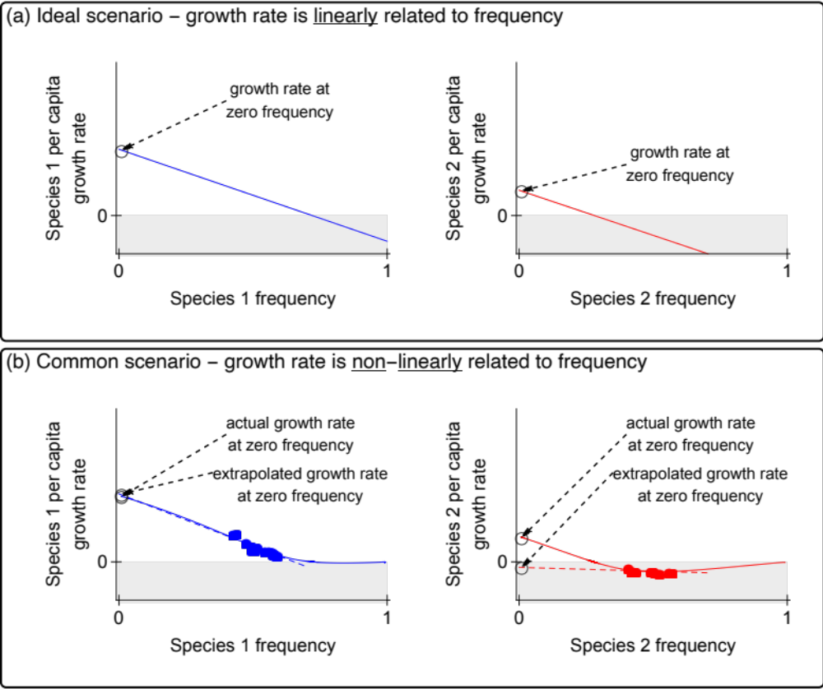
Supplementary Material Appendix C Figure C1: Panel a shows a hypothetical situation where species frequencies are linearly related to their growth rate and an empiricist can extrapolate to predict growth rates at frequency of zero and diagnose mutual invasibility. Panel b shows the more likely scenario in which growth rates are non-linearly dependent upon species frequencies. These plots were made using numerical simulation of the two-species Lotka Volterra Model, using parameter values that should allow for coexistence (at frequency of 0.72 for species 1). The points in Panel b represent measurements collected at intermediate frequency of both species. Using those measurements and extrapolating to zero frequency yields the incorrect prediction that the species will not coexist.

Supplementary Material Appendix D: Simplification of ND and RFD terms from Tilman’s Consumer Resource Model

Letten and others (2017) showed how the parameters in Tilman’s consumer resource model can be re-arranged to give estimates of inter- and intraspecific interaction coefficients and thus estimates of ND and RFD. As described in the main text of this paper, the equations specified depend upon which resource limits the growth of each species and their supplement gives all of the permutations for two species and two essential resources. Here we show how equations from Letten et al. (2017) can be simplified to get Equations 17 and 18 for the condition where species 1 is limited by resource 2 and species 2 is limited by resource 1. Their equations for inter- and intra-specific interaction coefficients for this condition are (their Equations S16.1, S16.2, S16.3, and S16.4):
$a_{11}=\frac{c_{12}}{D(S_{2}-R_{12}^{*})}, a_{12}=\frac{c_{22}}{D(S_{2}-R_{12}^{*})},a_{21}=\frac{c_{11}}{D(S_{1}-R_{21}^{*})},a_{22}=\frac{c_{21}}{D(S_{1}-R_{21}^{*})}$ (D1)
And their equations for the R* values that limit each species are (Equations S13.1 and S13.2):
$R_{12}^{*}=\frac{D{ k}_{12}}{r_{1}-D}, R_{21}^{*}=\frac{D{ k}_{21}}{r_{2}-D}$ (D2)
The consumption terms (e.g. c_{ii}) used by Letten et al. are represented in Equations 15 and 16 of this paper, where the resources associated with the y and R* and k terms are selected based on the resource that limits each species and its competitor:
$c_{11}=\frac{r_{1}}{y_{11}}\frac{R_{12}^{*}}{R_{12}^{*}+k_{12}}, c_{12}=\frac{r_{1}}{y_{12}}\frac{R_{12}^{*}}{R_{12}^{*}+k_{12}}, c_{22}=\frac{r_{2}}{y_{22}}\frac{R_{21}^{*}}{R_{21}^{*}+k_{21}}, c_{21}=\frac{r_{2}}{y_{21}}\frac{R_{21}^{*}}{R_{21}^{*}+k_{21}}$ (D3)
Substituting the definitions of the consumption terms (D3) and R* values (D2) into the equations for interaction coefficients (D1), we get:

$a_{11}=\frac{r_{1}}{y_{11}}\frac{\frac{D{ k}_{12}}{r_{1}-D}}{\frac{D{ k}_{12}}{r_{1}-D}+k_{12}}\frac{1}{D(S_{2}-\frac{D{ k}_{12}}{r_{1}-D})}, a_{12}=\frac{r_{2}}{y_{22}}\frac{\frac{D{ k}_{21}}{r_{2}-D}}{\frac{D{ k}_{21}}{r_{2}-D}+k_{21}}\frac{1}{D(S_{2}-\frac{D{ k}_{12}}{r_{1}-D})}$
$a_{21}=\frac{r_{1}}{y_{11}}\frac{\frac{D{ k}_{12}}{r_{1}-D}}{\frac{D{ k}_{12}}{r_{1}-D}+k_{12}}\frac{1}{D(S_{1}-\frac{D{ k}_{21}}{r_{2}-D})}, a_{22}=\frac{r_{2}}{y_{21}}\frac{\frac{D{ k}_{21}}{r_{2}-D}}{\frac{D{ k}_{21}}{r_{2}-D}+k_{21}}\frac{1}{D(S_{1}-\frac{D{ k}_{21}}{r_{2}-D})}$ (D4)
The terms listed in D4 are arguably messy, which explains why Letten and others simplified terms of R* and c_{ii}. Fortunately, when these interaction terms are used in Equations 3 and 4 they simplify to the form in the main text:
$ND=1- \sqrt{\frac{y_{12}y_{21}}{y_{11}y_{22}}}$
$$RFD= \sqrt{\frac{{\left(\frac{D k_{21}}{D-r_{2}}+S_{1}\right)}^{2}y_{11}y_{21}}{{\left(\frac{D k_{12}}{D-r_{1}}+S_{2}\right)}^{2}y_{12}y_{22}}}$$

